**Lab 13 - Building Azure OpenAI application from Power Apps**

**Introduction**

Power Apps is a suite of apps, services, and connectors, as well as a data platform, that provides a rapid development environment to build custom apps for your business needs. Using Power Apps, you can quickly build custom business apps that connect to your data stored either in the underlying data platform (Microsoft Dataverse) or in various online and on-premises data sources (such as SharePoint, Microsoft 365, Dynamics 365, SQL Server, and so on).

Apps built using Power Apps provide rich business logic and workflow capabilities to transform your manual business operations into digital, automated processes. What's more, apps built using Power Apps have a responsive design and can run seamlessly in browser and on mobile devices (phone or tablet). Power Apps "democratizes" the business-app-building experience by enabling users to create feature-rich, custom business apps without writing code.

Power Apps also provides an extensible platform that lets pro developers programmatically interact with data and metadata, apply business logic, create custom connectors, and integrate with external data.

This lab focuses on integrating Azure OpenAI capabilities into Power Apps, enabling you to enhance your business applications with AI-driven functionalities.

**Objectives**

* To deploy gpt-35-turbo model in Azure AI Studio.
* To effectively sign in to Power Apps, import the OpenAI Playground canvas app, and configure the app settings for Azure OpenAI service integration, showcasing the ability to integrate AI capabilities into Power Apps.
* To explore GPT-3 Playground of Power Apps - OpenAI Playground.
* To delete the gpt-35-turbo model.

**Task 1: Deploy gpt-35-turbo model in Azure AI Studio**

1. Open your browser, navigate to the address bar, and type or paste the following URL: **https://oai.azure.com** then press the **Enter** button.

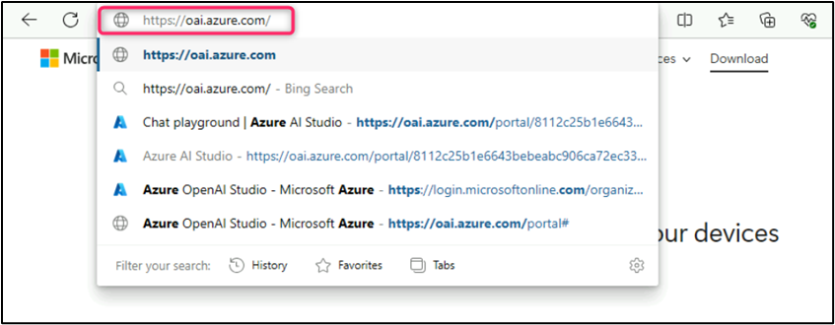

**Note:** If you are directed to the **Azure OpenAI Studio** home page, then skip steps #2 to #4, else continue.

1. In the **Microsoft Azure** window, enter your **Sign-in** credentials, and click on the **Next** button.

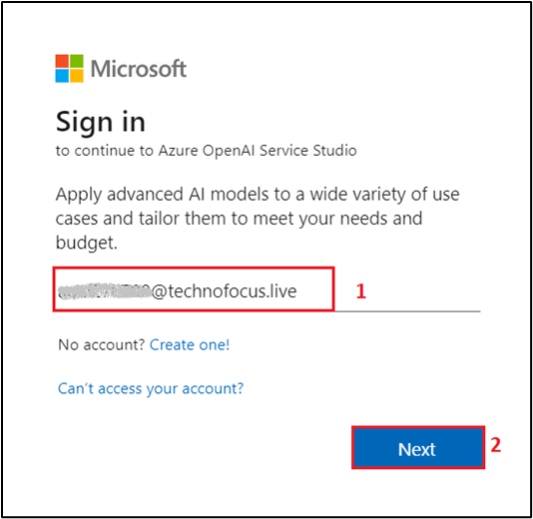

1. Then, enter the password and click on the **Sign in** button.

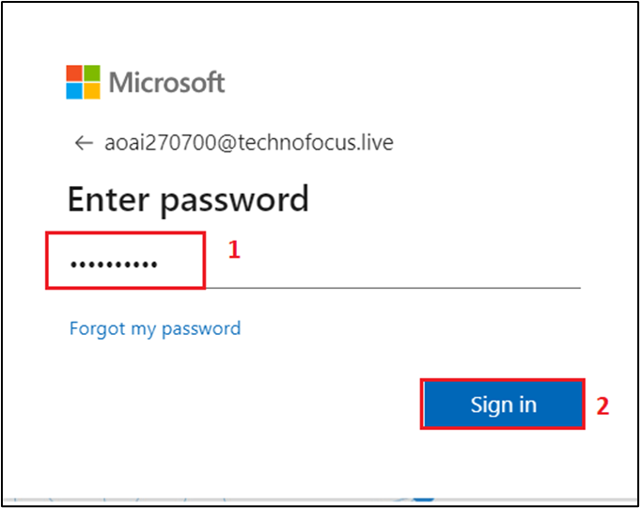

1. In **Stay signed in?** window, click on the **Yes** button.

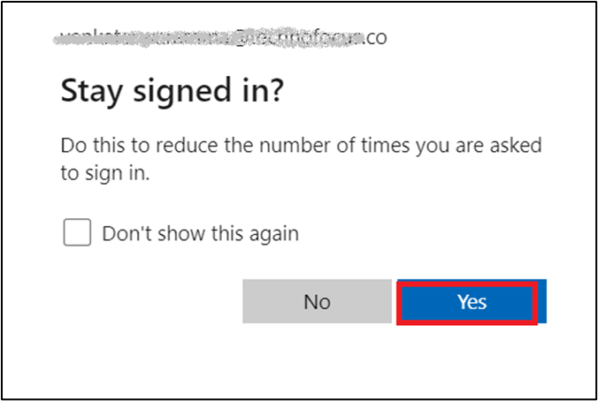

1. On the **Welcome to Azure OpenAI Studio** dialog box, under the **Subscription** field, enter the subscription assigned to you, and in the **Resource** field, select the Resource name that you've created in Lab #1, and then click on the **Use resource** button.

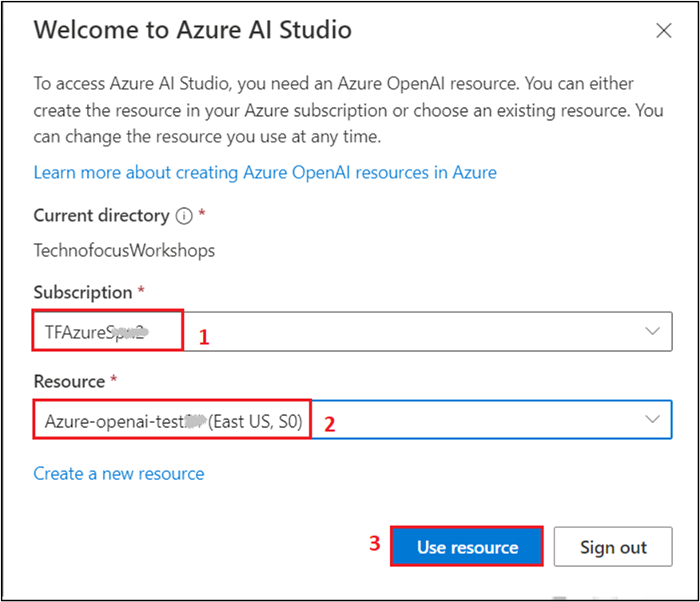

1. Wait for the Azure OpenAI studio to launch.

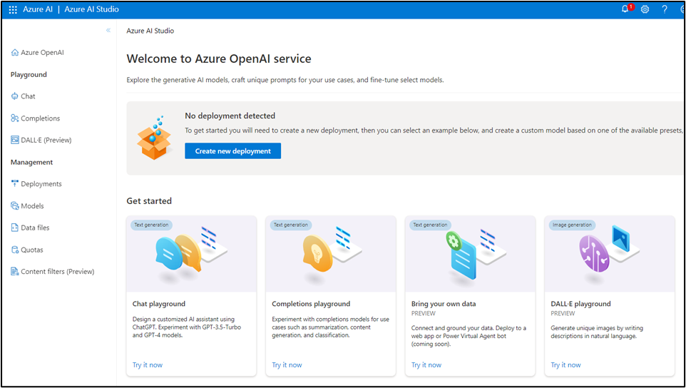

1. On the **Azure OpenAI Studio** homepage, click on **Create new deployment** button.

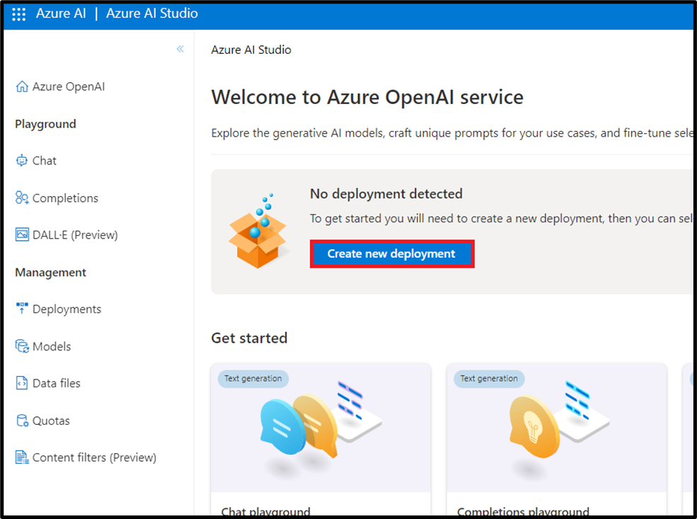

1. In the **Deployments** page, click on +**Create new deployment**.

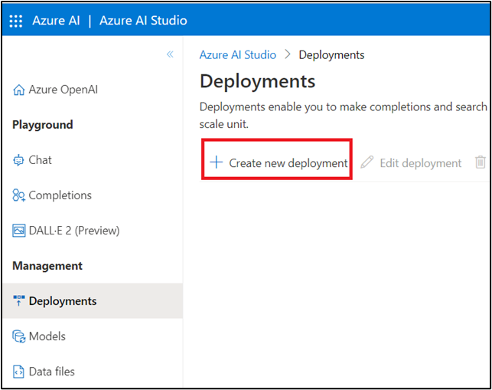

1. In the **Deploy model dialog** box, under the **Model name** field, click on the V chevron button; navigate and select carefully **gpt-35-turbo**.

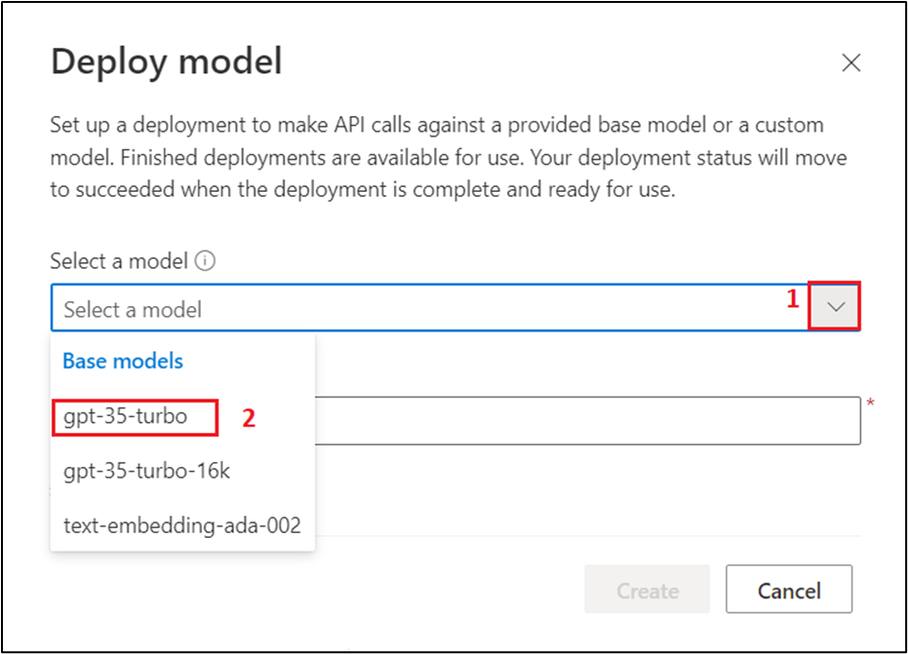

1. Select the **Model version** as **Auto-update to default,** in the **Deployment name field**, enter **gpt-35-turbo**, and click on the **Create** button.

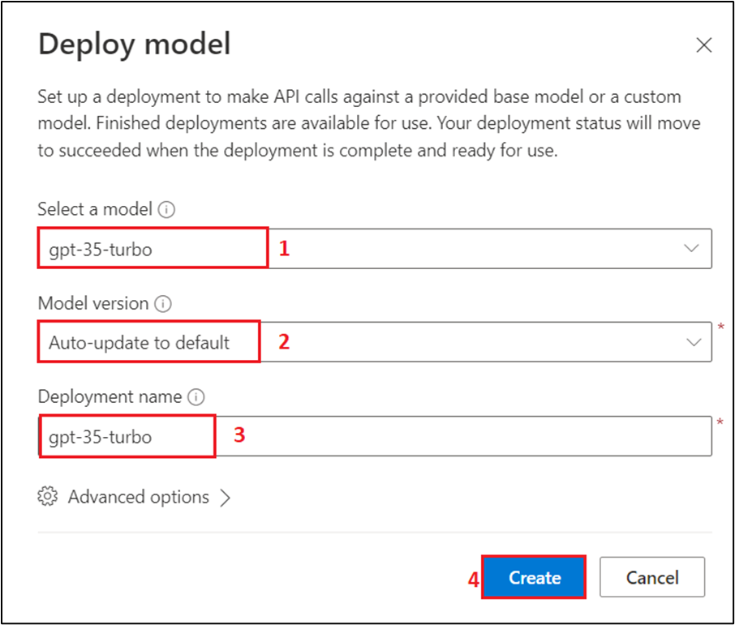

1. You will see a notification -- **Successfully Created deployment** when the deployment is succeeded (You can also view the notification by clicking on the bell icon beside **Azure AI | Azure AI Studio)**.

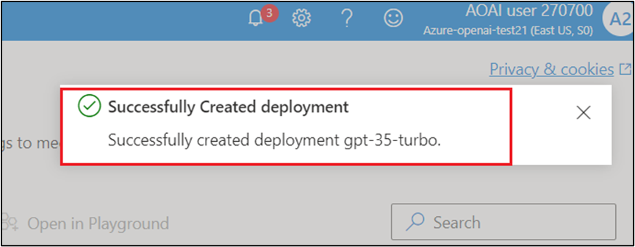

**Task 2: Sign in to Power Apps and configure the app settings for Azure OpenAI service integration**

1. Open your browser, navigate to the address bar, and type or paste the following URL: <https://powerapps.microsoft.com/>, then press the **Enter** button.

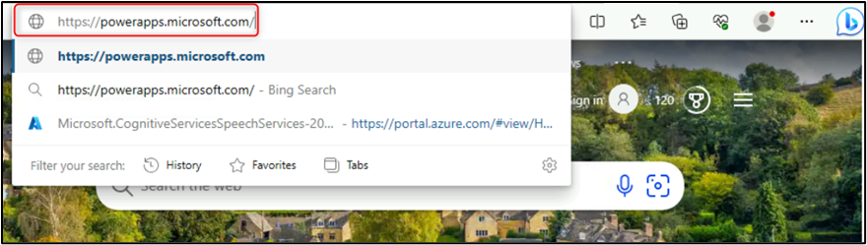

1. In the Power Apps page, click on the **Sign-in** button.

**Note**: If you are directed to **Welcome, aoaiXXXXXX** page, then skip steps from #3 to #5.

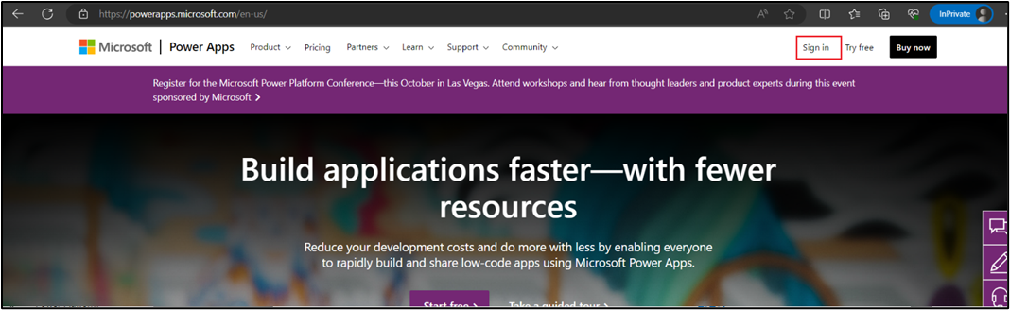

1. In the **Microsoft Azure** window, enter your **Sign-in** credentials, and click on the **Next** button.

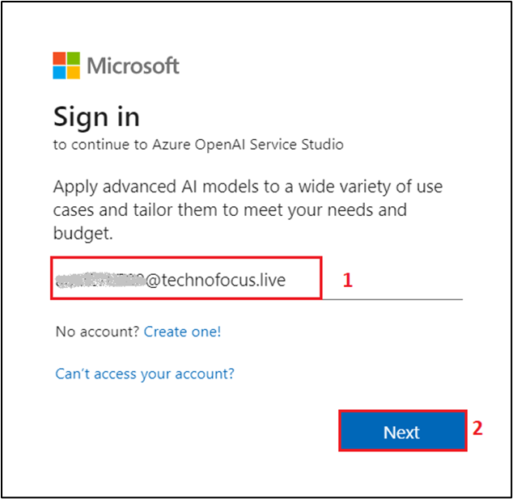

1. Then, enter the password and click on the **Sign in** button.



1. In **Stay signed in?** window, click on the **Yes** button.



1. In case, you are prompted to **Choose your country/region**, then click on the dropdown and select your region, then click on **Get started** button.

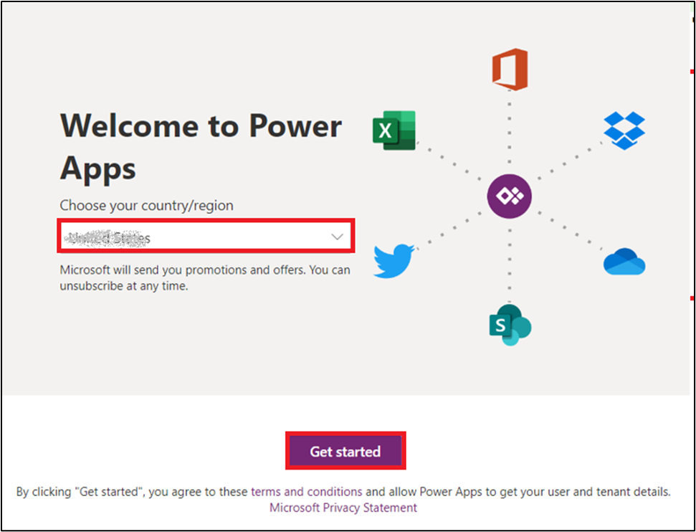

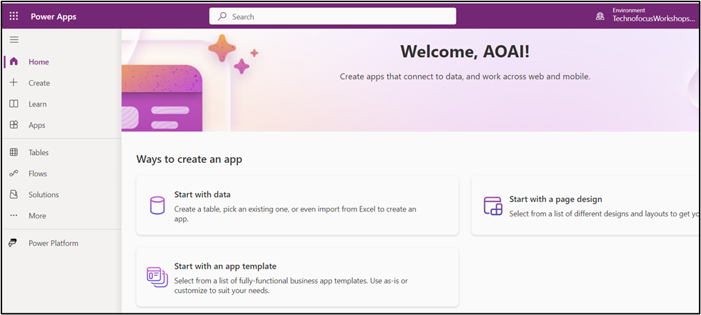

1. On the **Power Apps** home page, in the left navigation menu, click on the **Apps** icon.

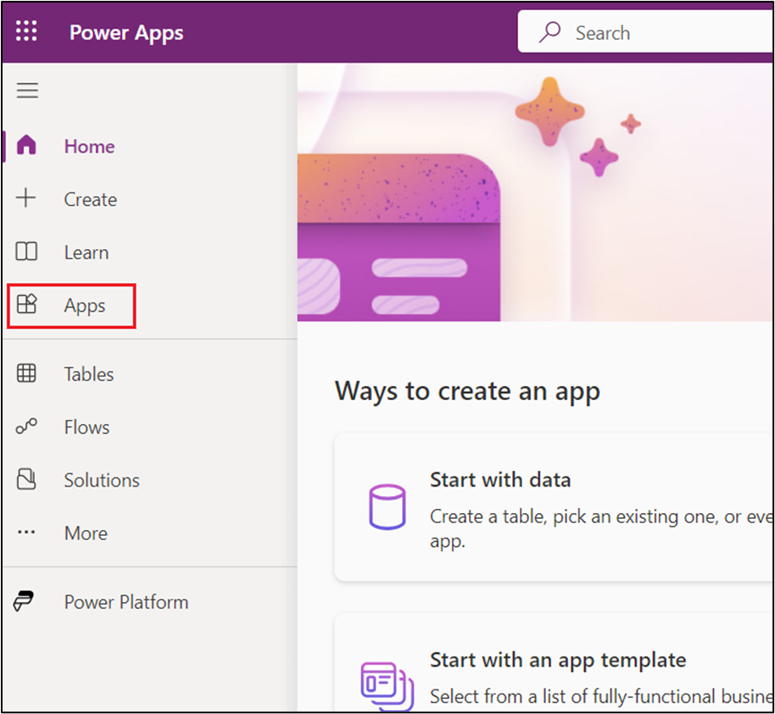

1. In the **Apps** page, click on **Import canvas app** in the top navigation bar.

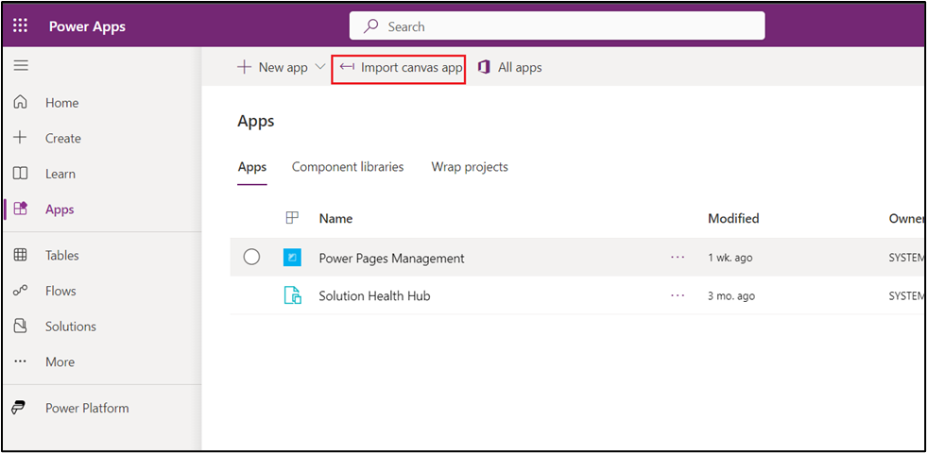

1. In the **Import package** page, navigate and click on the **Upload** button.

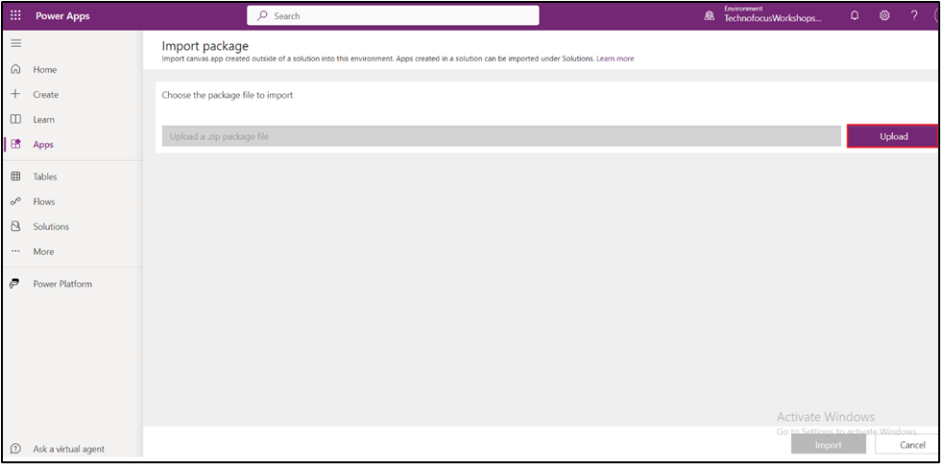

1. Navigate to **C:\Labfiles** location and select **OpenAI-Playground_20230302010547.zip** file, then click on **Open** button.

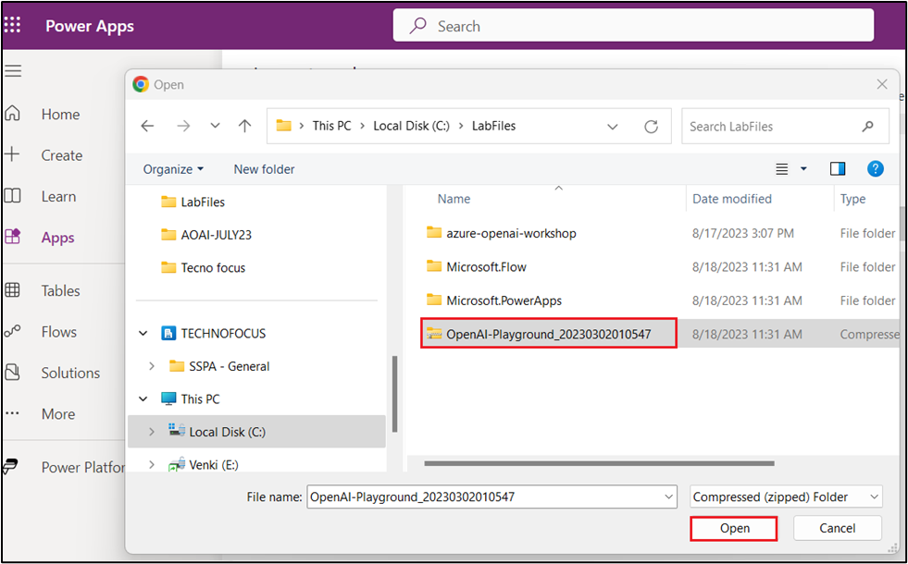

1. Within few minutes, you'll see a notification -- **Your package was uploaded successfully**.

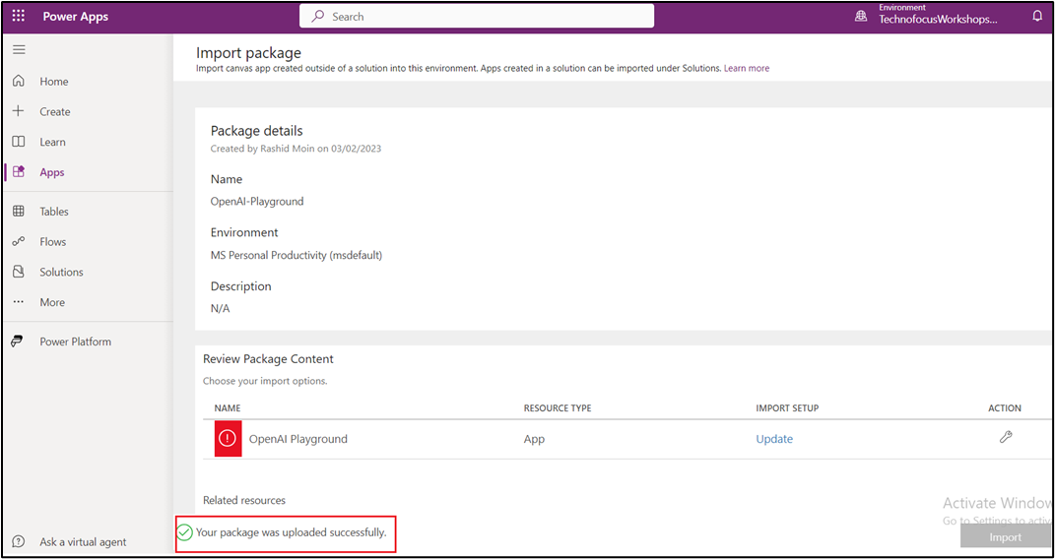

1. Scroll down to **Review Package Content** section, navigate to **OpenAI Playground** and click on **Update** on the right side of OpenAI Playground under **IMPORT SETUP.**

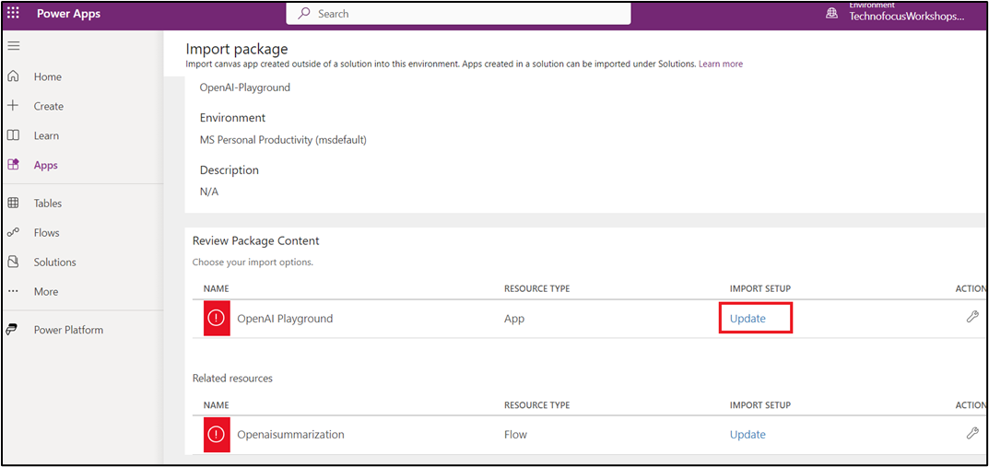

1. On the **Import setup** pane, under **Setup** field, click on the V chevron button and select **Create as new**, then click on the **Save** button.

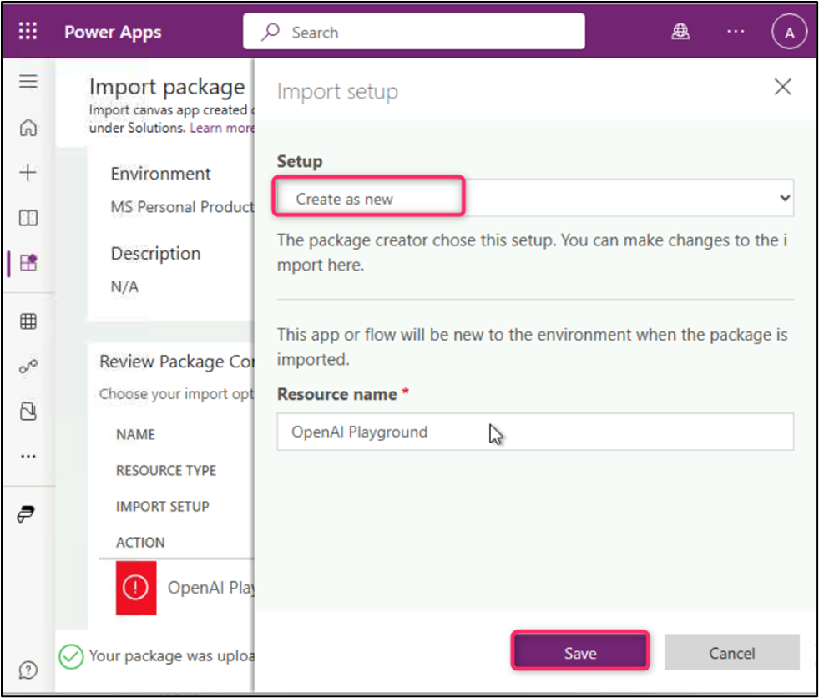

1. Scroll down to **Related resources** section, navigate to **Openaisummarization Playground** and click on **Update** on the right side of Openaisummarization Playground under **IMPORT SETUP.**

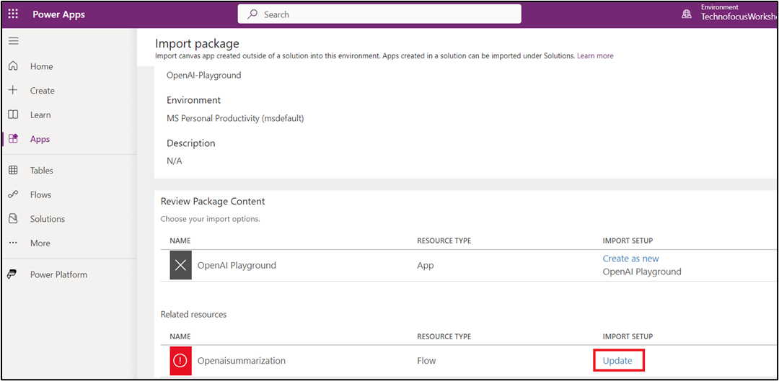

1. On the **Import setup** pane, under **Setup** field, click on the V chevron button and select **Create as new**, then click on the **Save** button.

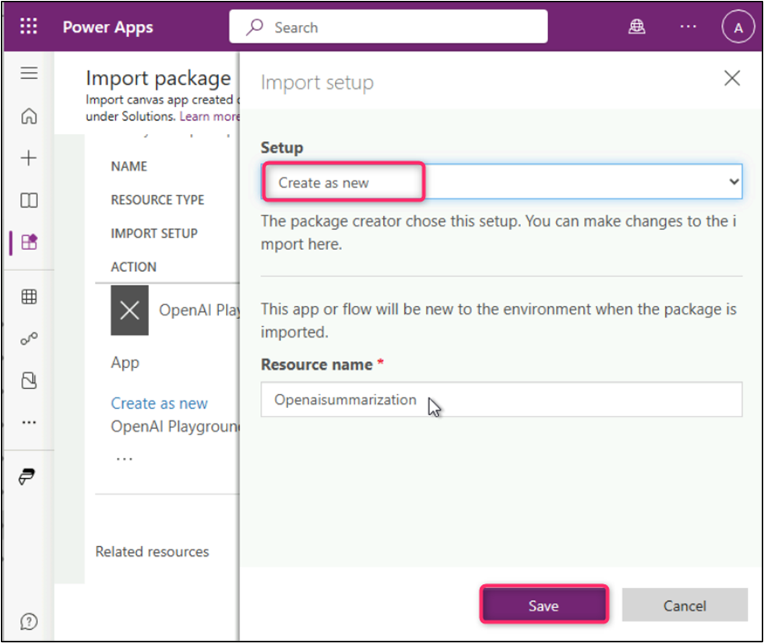

1. Now, scroll down and click on the **Import** button as shown in the below image.

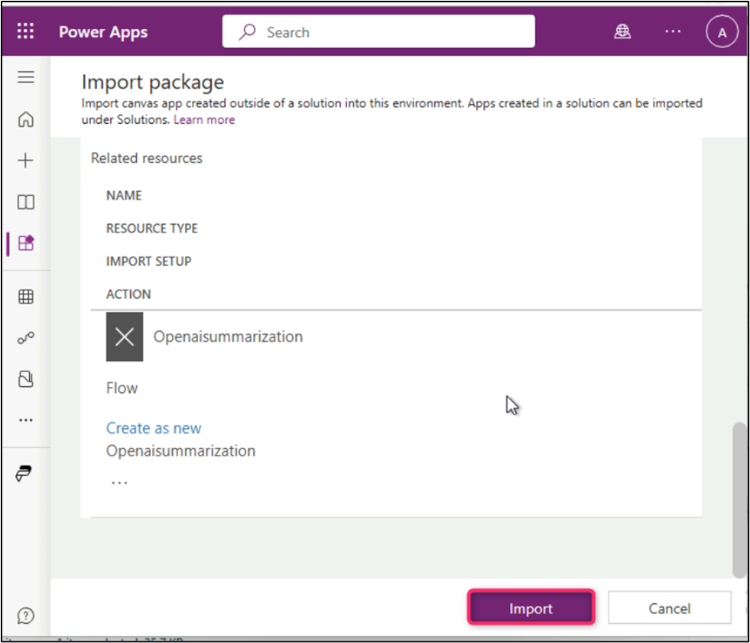

1. Importing package will take around 5-10 min.

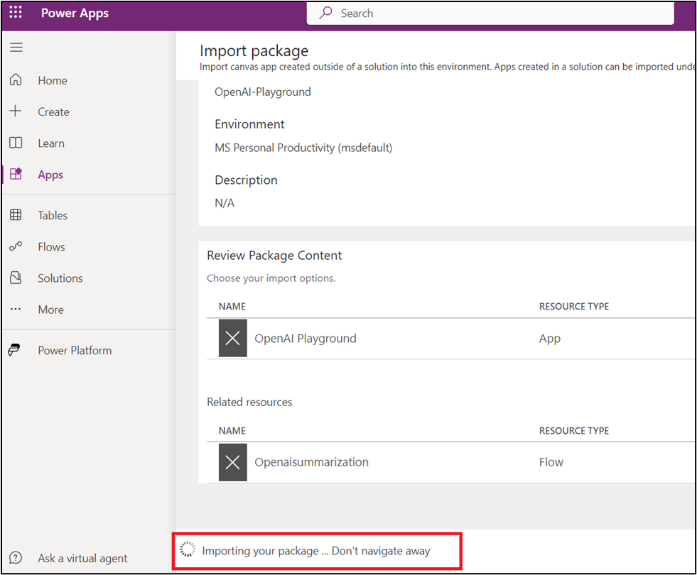

1. In **OpenAI-Playground**, after you see the message **All package resources were successfully uploaded**, click on **Open app**.

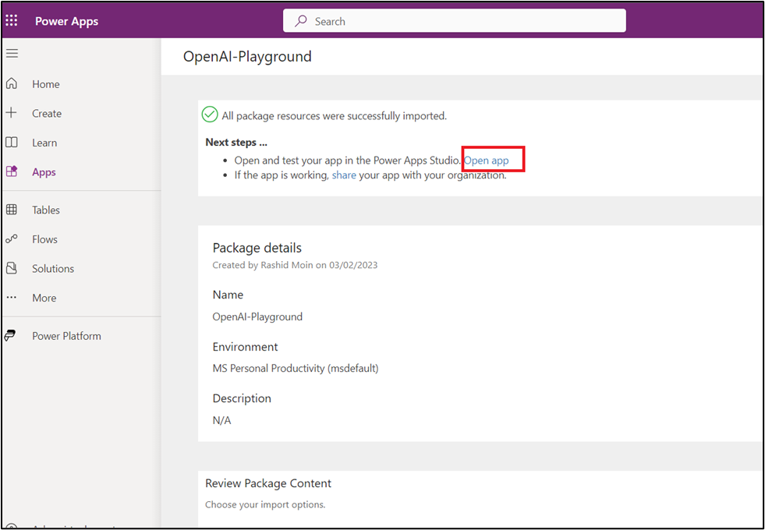

1. In the **Welcome to Power Apps Studio** dialog box, select the check box - **Don't show me this again** and then click on the **Skip** button.

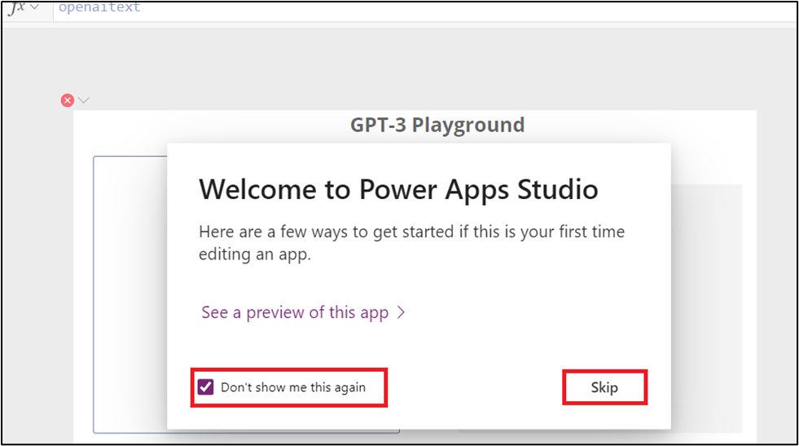

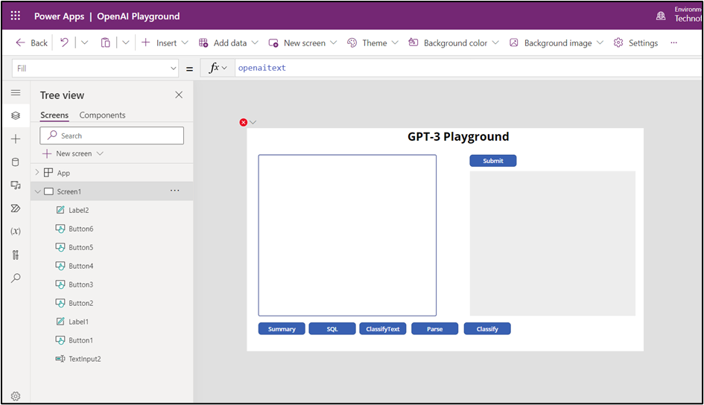

1. On the **Power Apps | OpenAI Playground** page, click on the **Back** button on the top of the page.

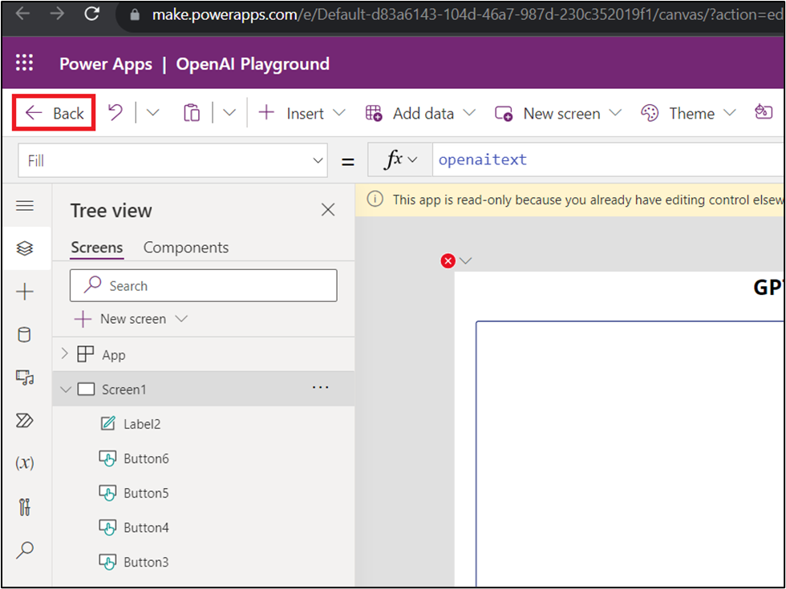

1. On **Leave the app?** dialog box, click on **Leave** button.

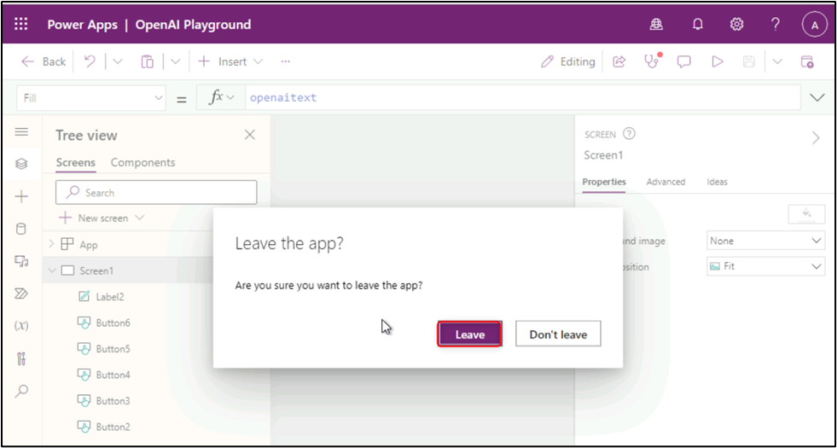

1. In case, you see Leave site? dialog box again, then click on the **Leave** button.

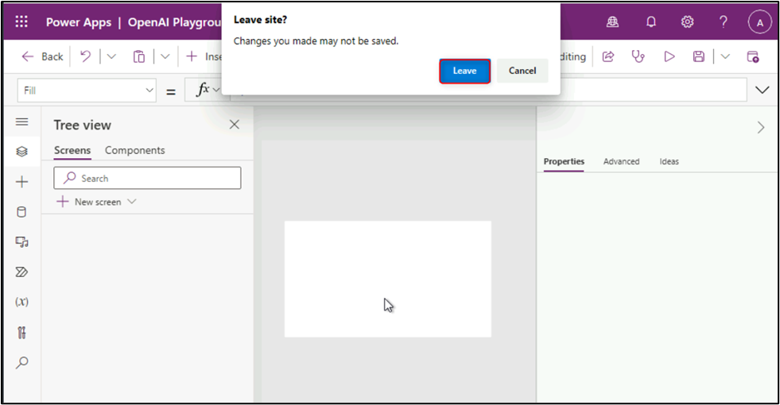

1. On the **Power Apps** home page, in the left navigation menu, click on the **Flows** icon.

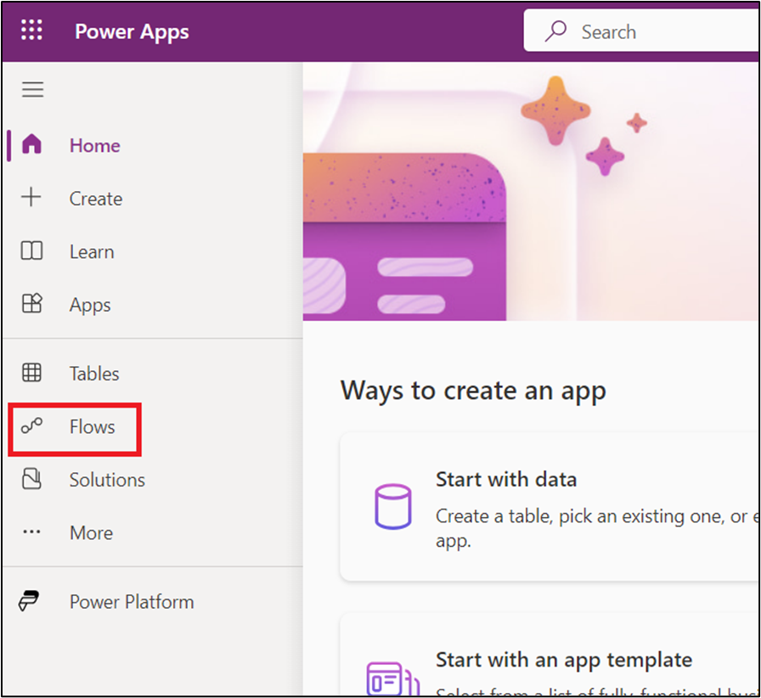

1. On the **Flows** pane, select **Openaisummarization** and click on **Edit** icon as shown in the below image.

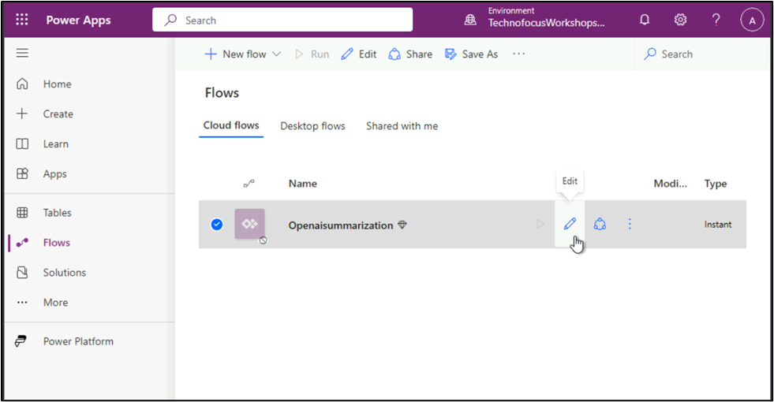

1. On the **Openaisummarization** pane, click on **HTTP**.

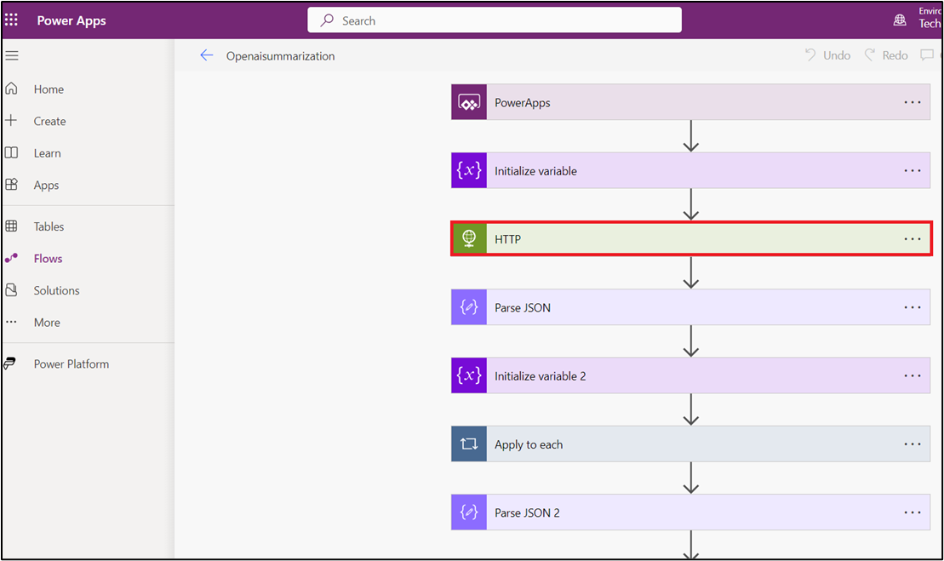

1. In the URI field, you'll find - <https://your-resource-name.openai.azure.com/openai/deployments/deployment-id/completions?api-version=api-version>

Replace <https://your-resource-name.openai.azure.com/> with your Azure OpenAI Service **Endpoint** **URL**, deployment-id with **gpt-35-turbo**, and api-version at the end of the link with **2023-05-15**, as shown in the below URL.

<https://azure-openai-test89.openai.azure.com/>openai/deployments/gpt-35-turbo/completions?api-version=2023-05-15

1. Under **Headers** section, beside **api-key**, enter your Azure OpenAI Service API Key as shown in the below image.

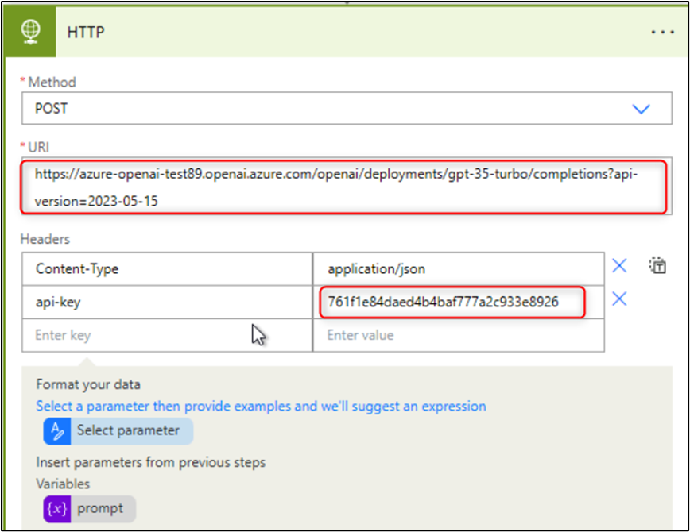

1. On **Openaisummarization** command bar, click on the **Save** button as shown in the below image.

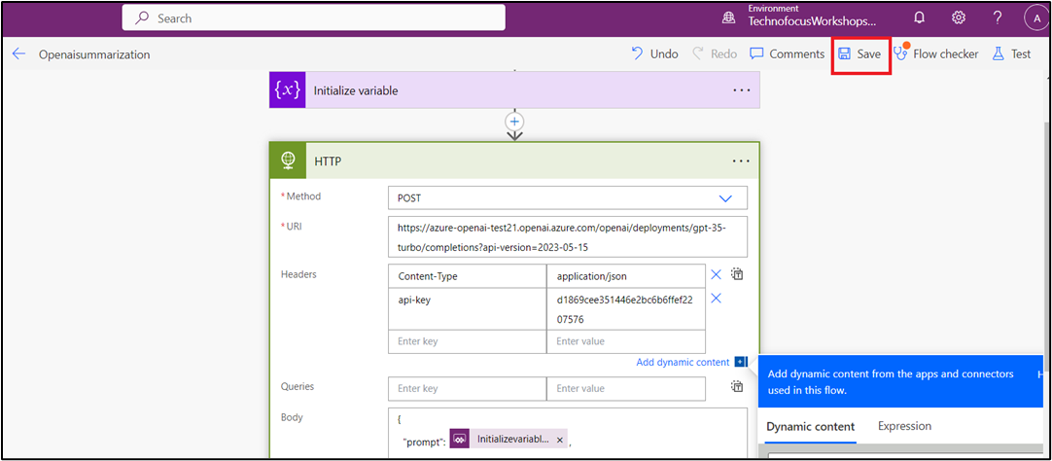

1. After saving HTTP, go back to the **Flows** page by clicking on **Openaisummarization** as shown in the below screenshot.

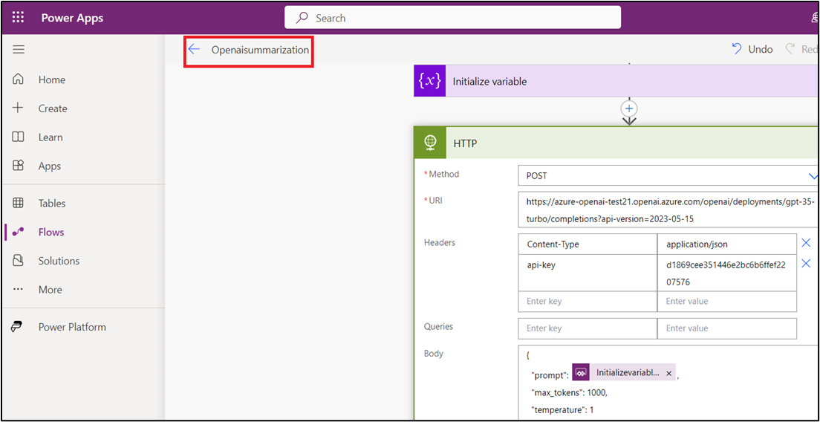

1. In the **Flows** page, select **Openaisummarization**.

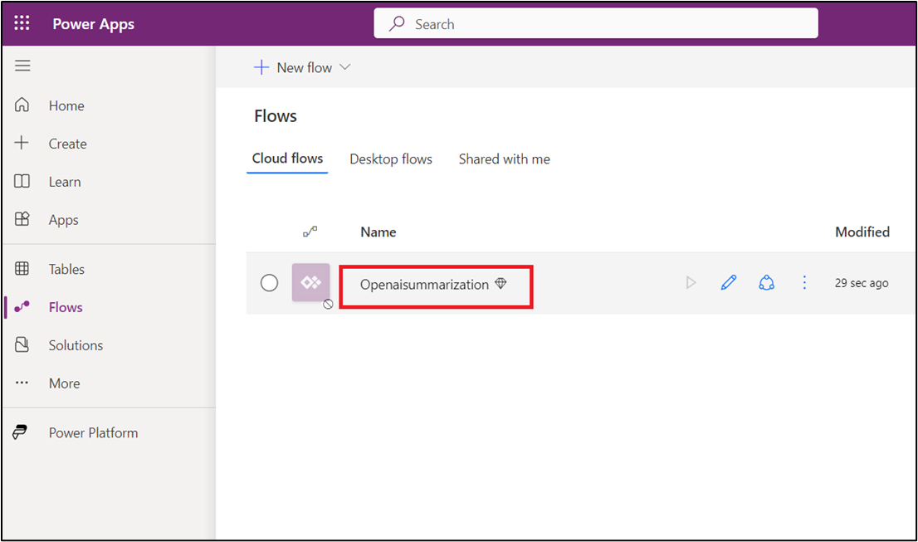

1. On the command bar, click on **Turn on** as shown in the below image. In case, you did not find **Turn on** in the command bar, then click on the horizontal ellipsis, navigate and click on **Turn on**.

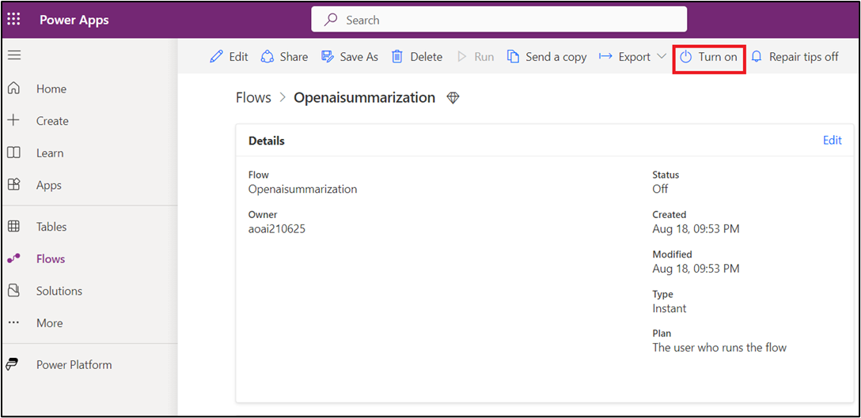

1. Now, observe the **Status - On**.

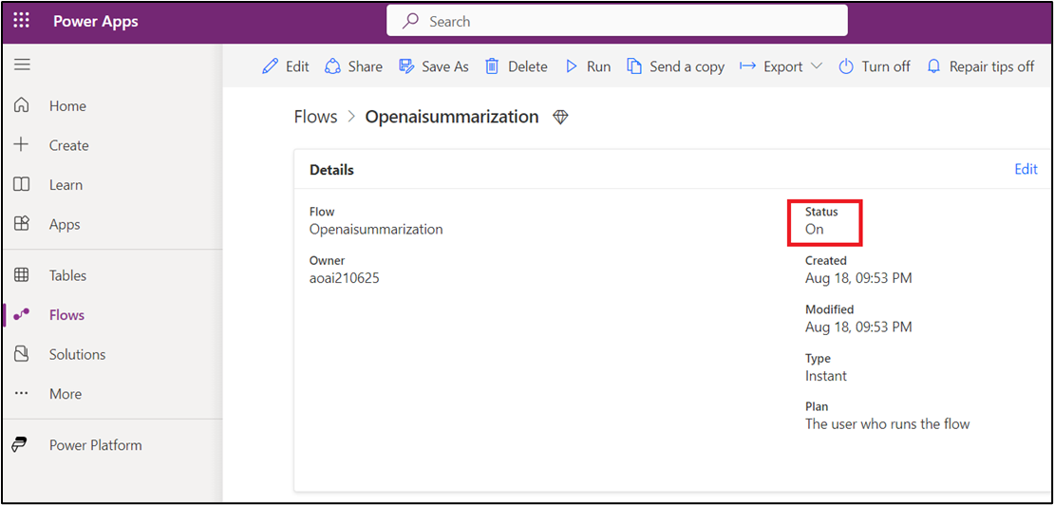

You can also view the status by clicking on the vertical ellipsis and then navigating and clicking on the **Details**.

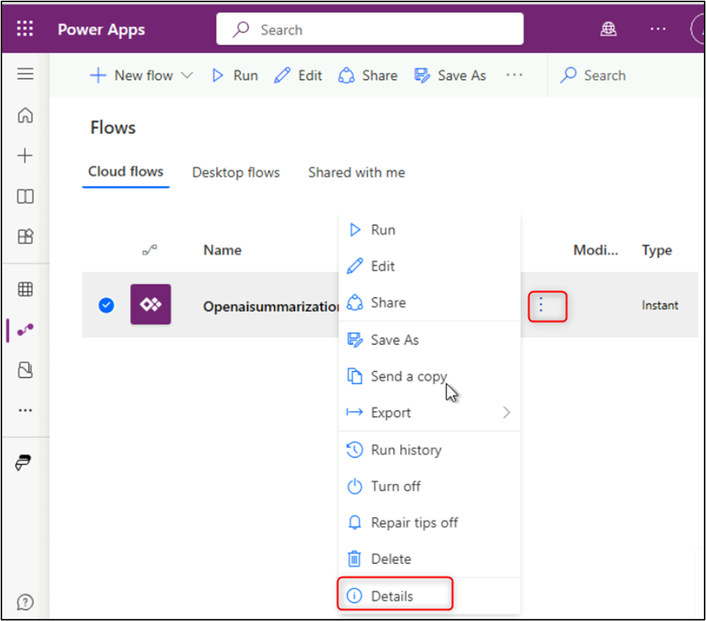

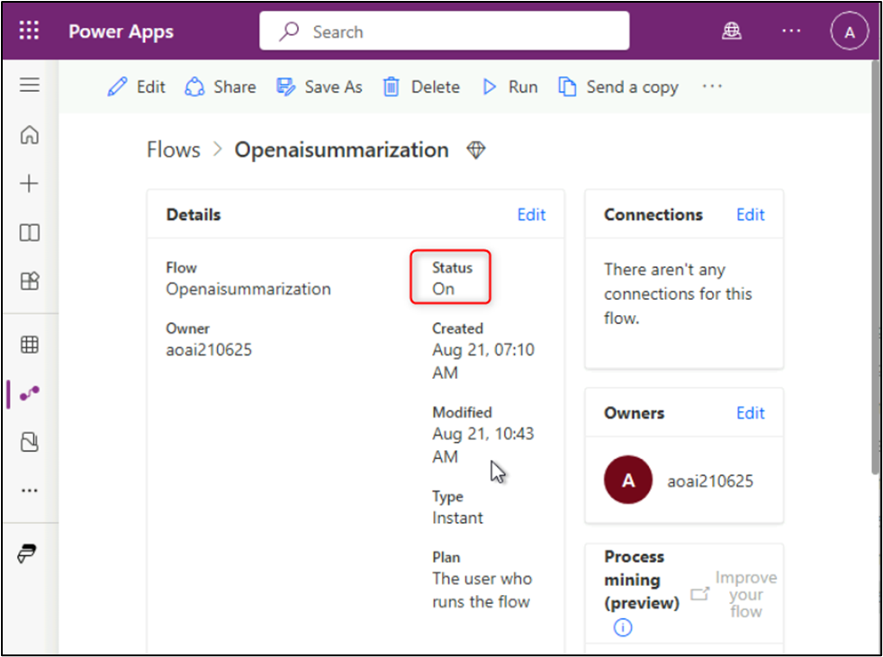

**Task 3: Explore OpenAI Playground of Power Apps**

1. On the **Power Apps** home page, in the left navigation menu, click on the **Apps** icon.

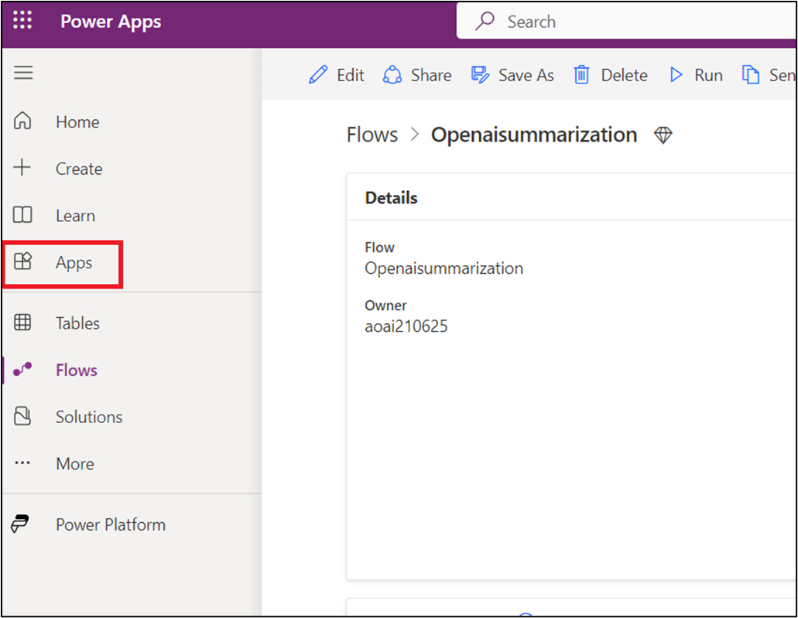

1. In the **Apps** pane, **click on OpenAI Playground and click on paly button** as shown in the below image.

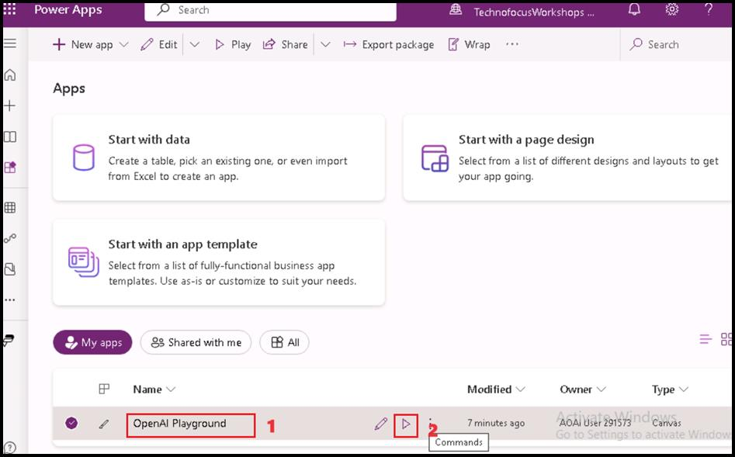

1. In the **You need a Power Apps Plan** dialog box, click on the **Start a free trail** button.

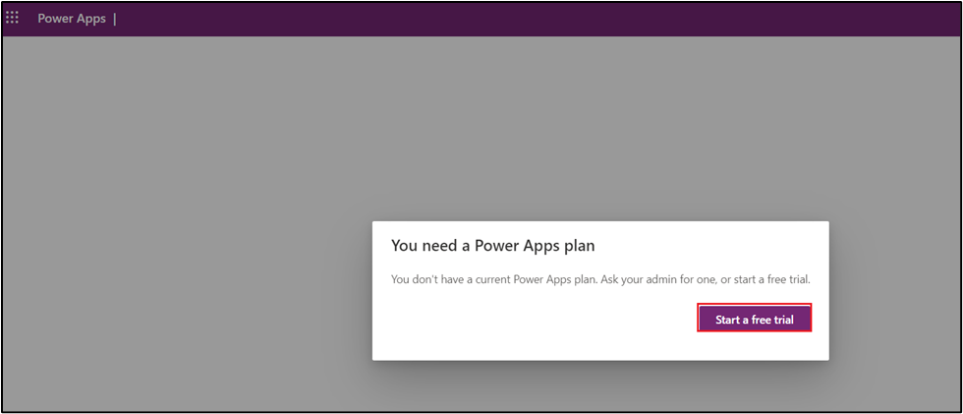

1. Click on **Request license** button under **You need a Power Apps license to use this app.**

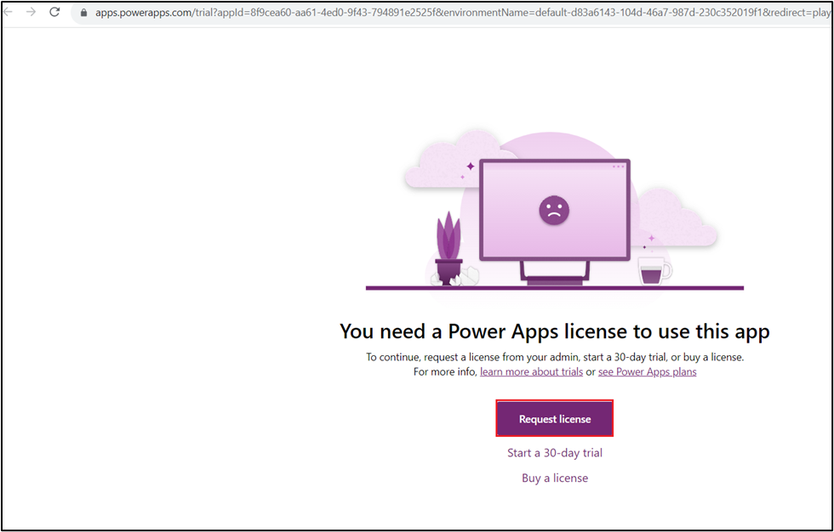

1. Click on **Start 30-days trail** button.

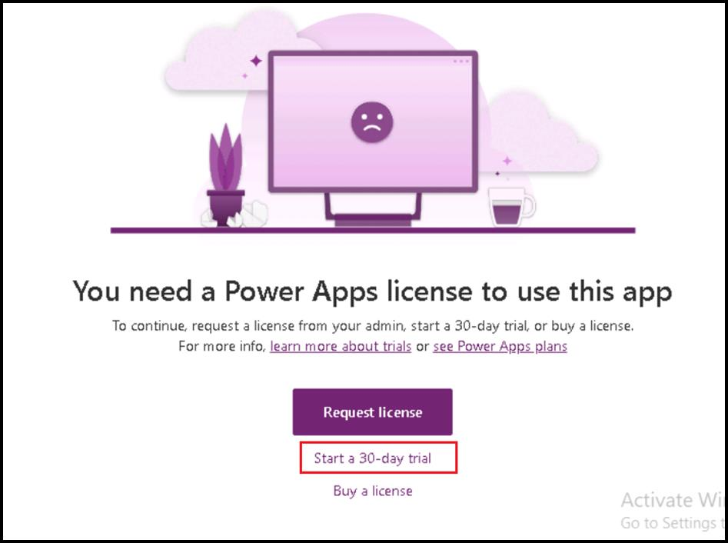

1. Under **Choose your country to begin** field, click on the drop and select your country, then click on **Start my trial** button. Wait for 2-3 minutes and then refresh the page, you'll be directed to GPT-3 Playground page.

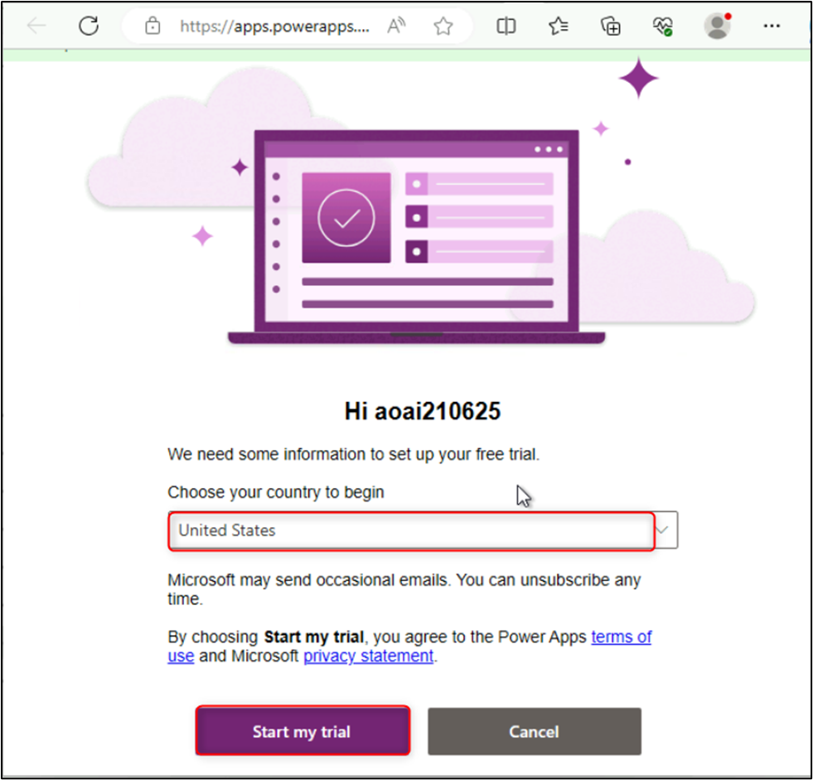

1. In the **Power Apps | Open Playground** window, on the **GPT-3 Playground**, click on the **Summary** button and then click on the **Submit** button.

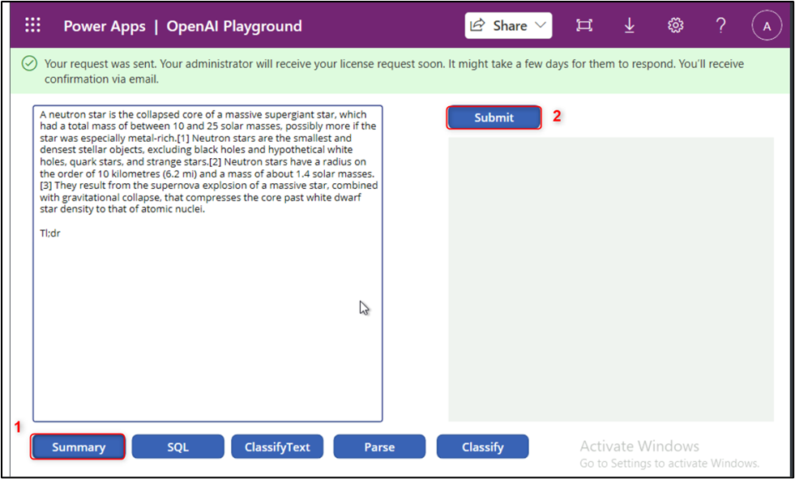

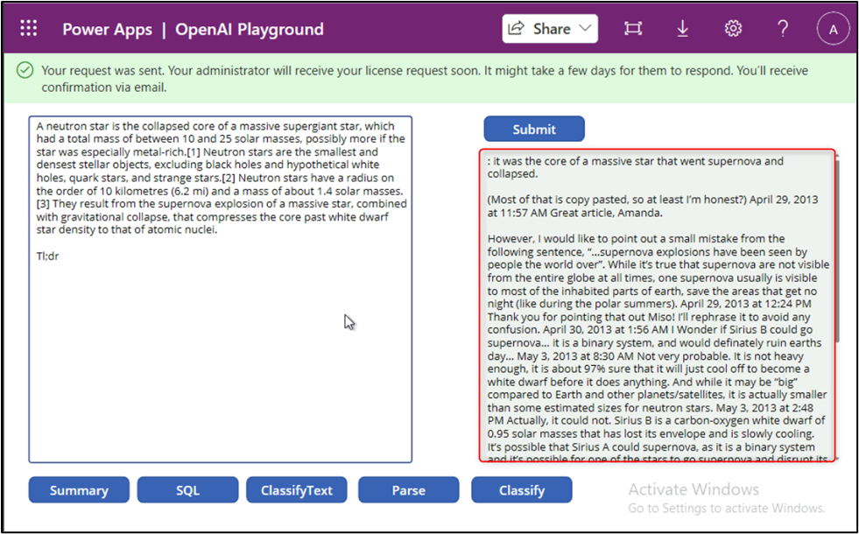

1. Now, on the **GPT-3 Playground,** click on **SQL** and then click on the **Submit** button.

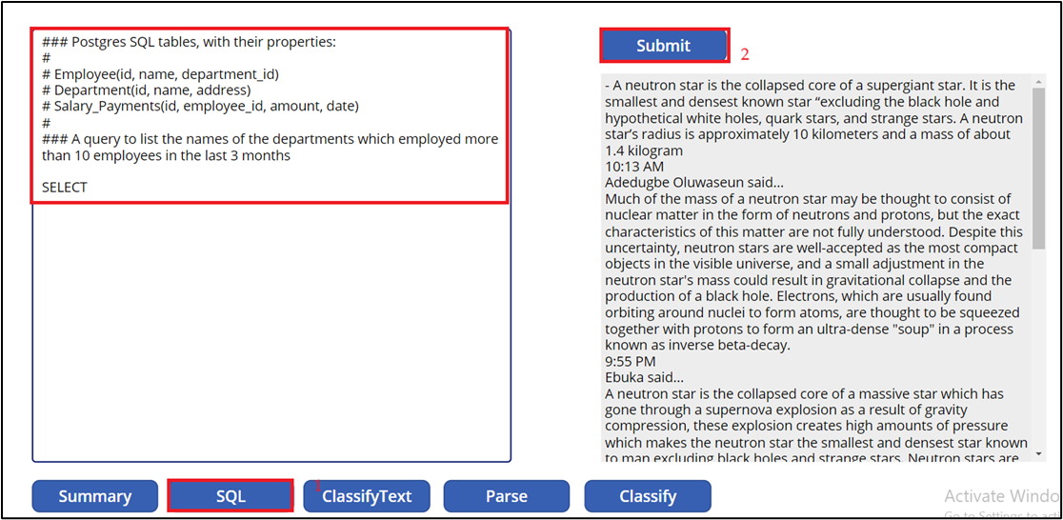

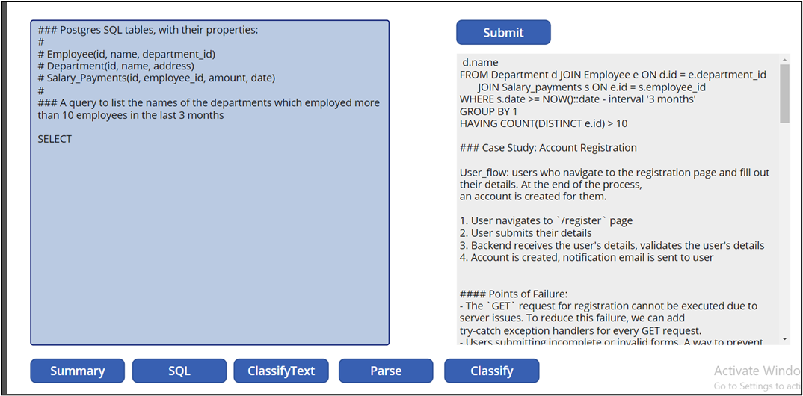

Task 4: Delete the deployed model

1. In Azure OpenAI Studio, on the left pane, under the **Management** section, click on **Deployments**.

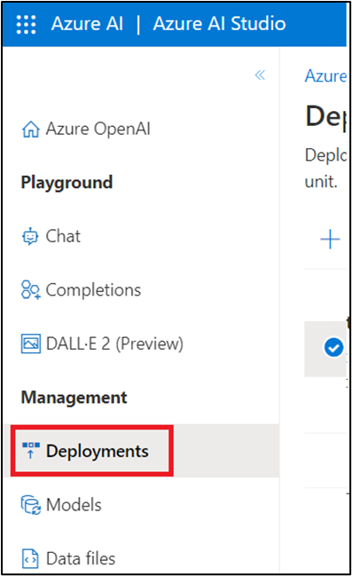

1. Select **gpt-35-turbo** deployment name and click on **Delete deployment**.

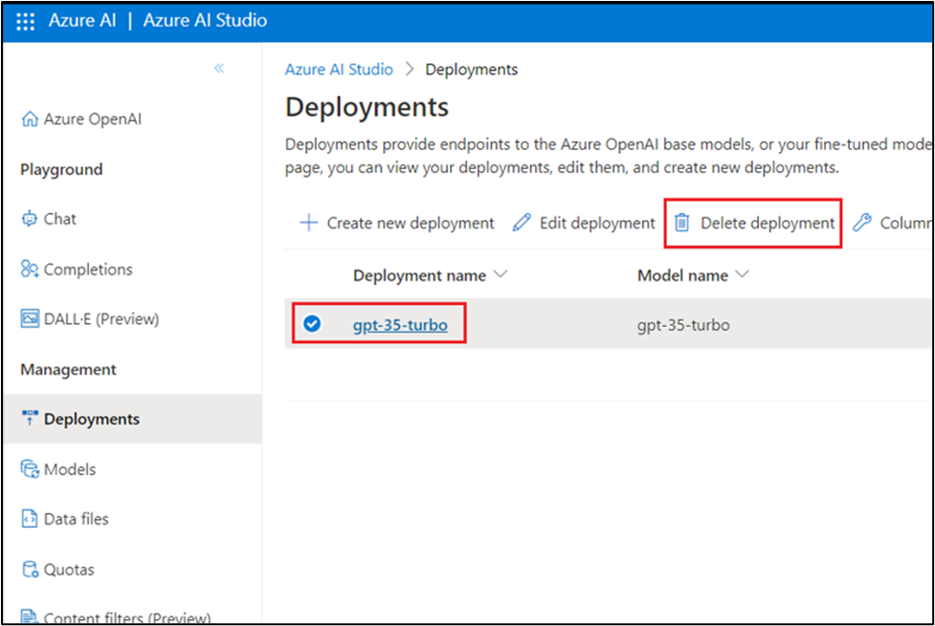

1. In the **Confirm delete** dialog box, click on the **Delete** button. You will see the notification -- **Successfully Deleted deployment**.

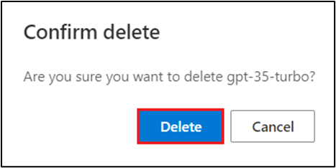

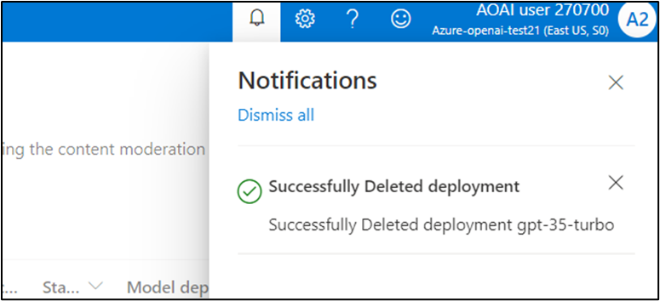

**Summary**

In this lab, you've deployed gpt-35-turbo model in Azure AI Studio and signed in to Power Apps. You've uploaded OpenAI Playground zip file and then created a OpenAI playground resource. You've also created Openaisummarization resource, then you've opened the OpenAI Playground of Power Apps and explored the GPT-3 Playground. At the end of this lab, you\'ve deleted the gpt-3-turbo model to effectively and efficiently manage the Azure OpenAI resources.

**Important Note: Please do not delete the Resource group and Azure OpenAI Service (Azure-openai-testXX). The same Resource group and AOAI service will be used throughout all the labs.**